ETL SCD1 using Snowflake Tasks, Streams and Stored Procedures

Objective:
This project implements a pipeline to handle full data loads and change data (CDC) file from a Python process, stores the data in AWS S3, and use Snowflake’s native features — Snowpipe, Streams, Tasks, and Stored Procedures — to automatically load and update a customer table with SCD Type 1 logic

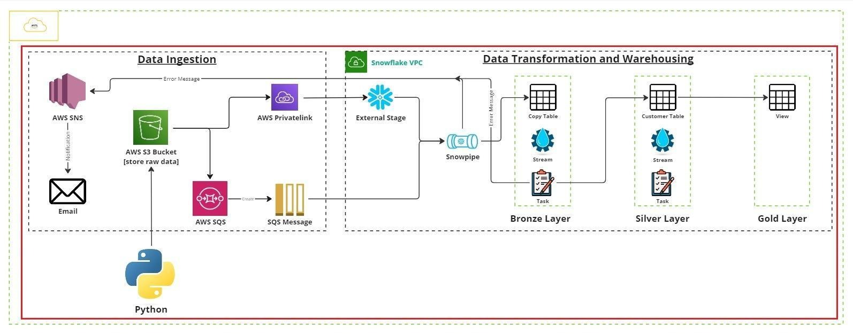

Process:
- Python scripts upload csv files to S3
- Snowpipe is setup using external stage with S3. This snowpipe continuously monitors the S3 external stage in Snowflake. (Benefit: Fully automated, near real-time ingestion without manual loading)
- A stream is defined on the CUSTOMER_SOURCE table to track new or changed rows that were loaded by Snowpipe. (Benefit: Snowflake knows exactly which rows are newor updated, making incremental processing simple).
- A Task runs on a schedule (or continuously) and calls a Stored Procedure
- The Stored Procedure:
  - Reads the change data from the Stream.
  - Merges it into the target CUSTOMER table using SCD Type 1 logic:
  - If the customer ID exists → update the changed attributes (e.g., overwrite address or email).
  - If the customer ID is new → insert it.
  - This is typically done using a MERGE statement.
(Benefit: The entire SCD1 flow is automated — no manual steps to merge data).

